**ASSIGNMENT 12**

Ria Mittal

322010

T.E. B - B1

5 mongo db queries

> db.student.distinct("name");

[

"ria",

"ankita",

"apurva",

"honey",

"pranav",

"priyanka",

"rakhi",

"ria",

"rohit",

"saee",

"utkarsh"

]

> db.student.distinct("age");

[ 19, 20, 21, 18 ]

> db.student.distinct("dept");

[ "comp", "mech", "it" ]

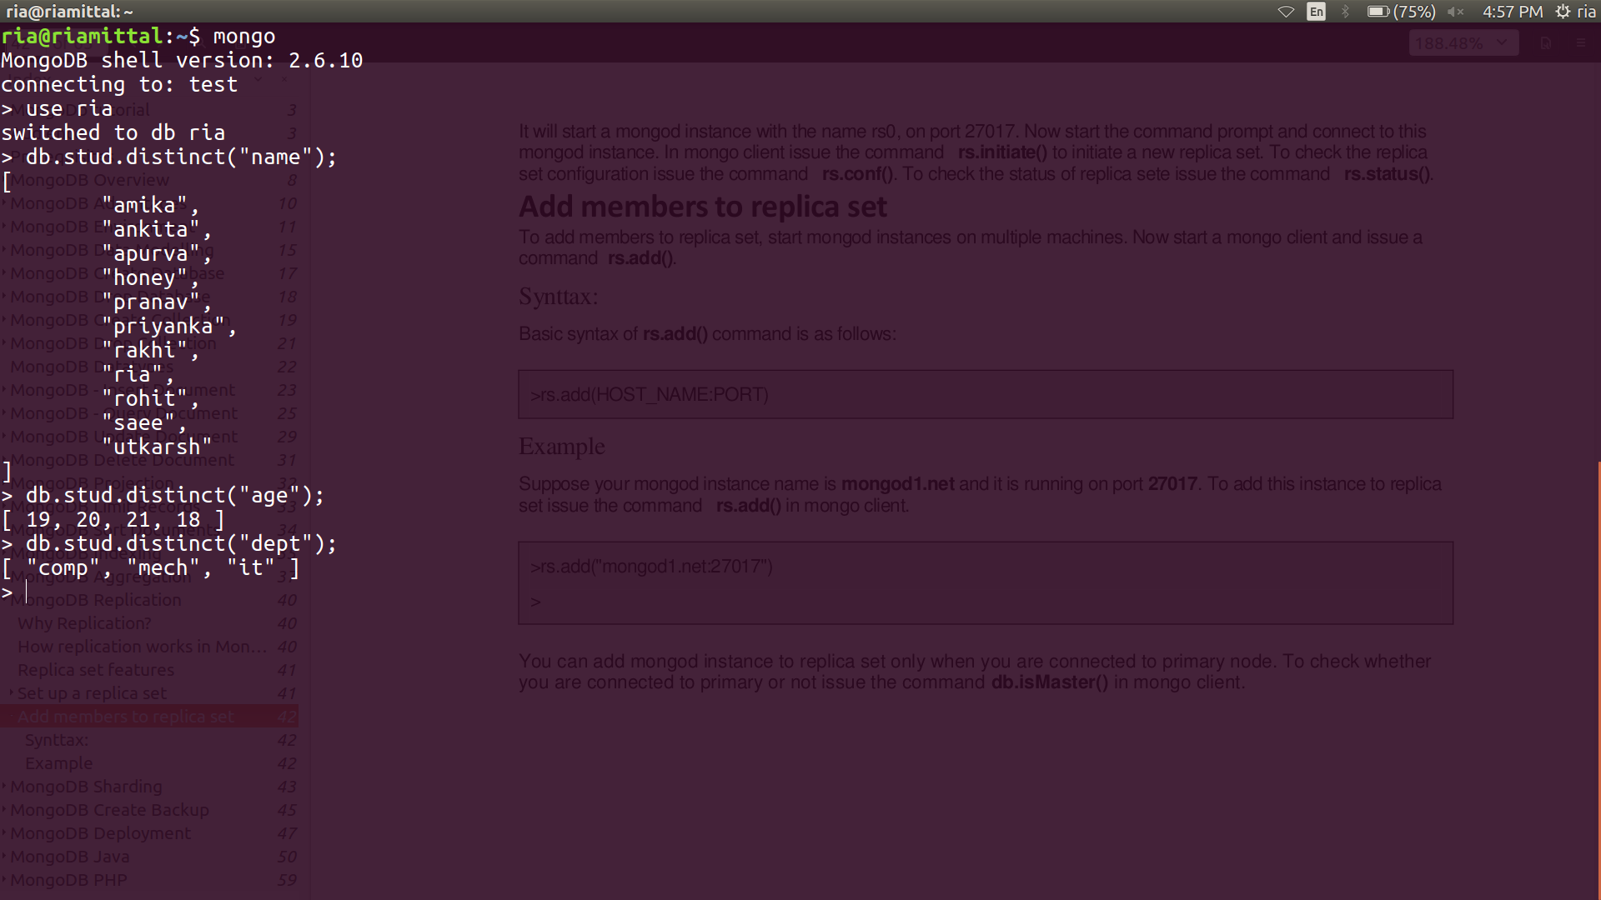

> db.student.dataSize();

1232

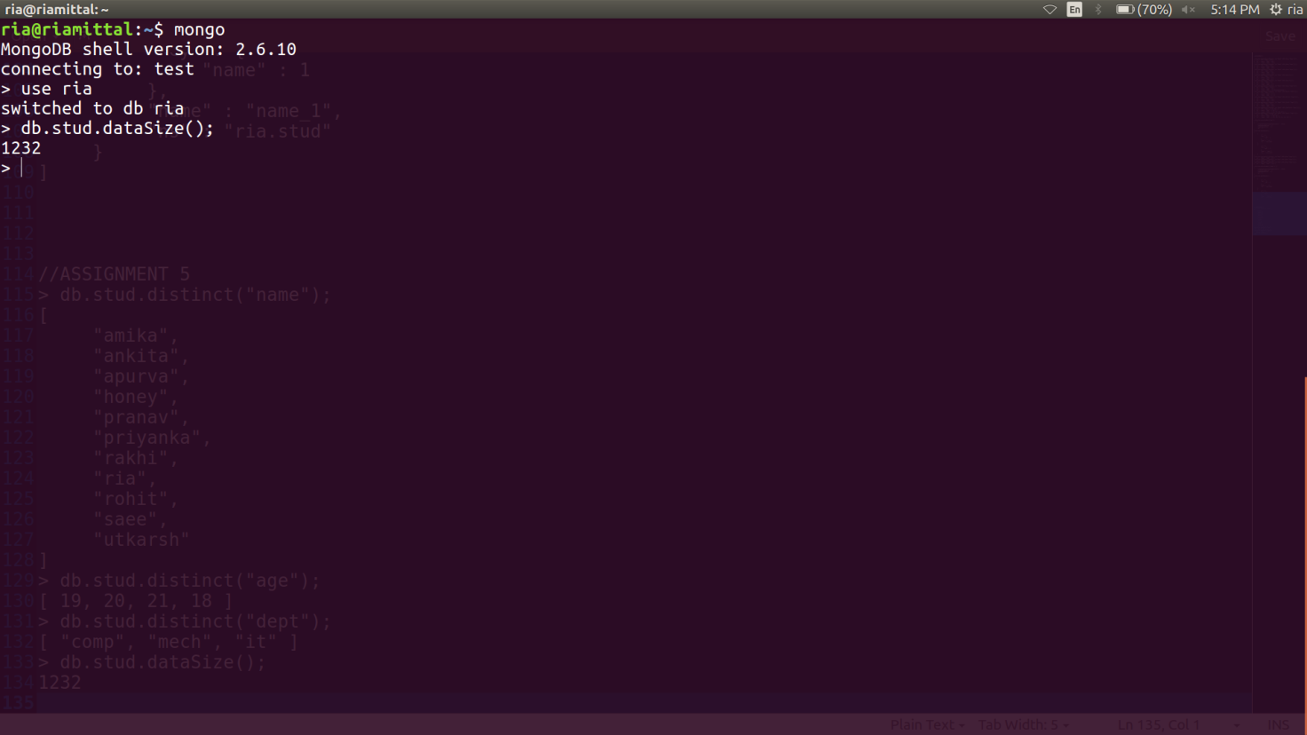

> db.student.find().sort({"name" : 1});

{ "_id" : ObjectId("5ba3792aad0d7c602a852b4f"), "name" : "ria", "age" : 19, "dept" : "comp" }

{ "_id" : ObjectId("5b88fa8640324e4c1835df69"), "name" : "ankita", "age" : 20, "dept" : "comp" }

{ "_id" : ObjectId("5b88faa140324e4c1835df6b"), "name" : "apurva", "age" : 20, "dept" : "mech" }

{ "_id" : ObjectId("5b88fadf40324e4c1835df70"), "name" : "honey", "age" : 18, "dept" : "comp" }

{ "_id" : ObjectId("5b88faf240324e4c1835df71"), "name" : "pranav", "age" : 19, "dept" : "comp" }

{ "_id" : ObjectId("5b88fac040324e4c1835df6e"), "name" : "priyanka", "age" : 19, "dept" : "it" }

{ "_id" : ObjectId("5b88fa9140324e4c1835df6a"), "name" : "rakhi", "age" : 19, "dept" : "comp" }

{ "_id" : ObjectId("5b88fa7a40324e4c1835df68"), "name" : "ria", "age" : 19, "dept" : "comp" }

{ "_id" : ObjectId("5b88fad440324e4c1835df6f"), "name" : "rohit", "age" : 21, "dept" : "comp" }

{ "_id" : ObjectId("5b88faa940324e4c1835df6c"), "name" : "saee", "age" : 20, "dept" : "mech" }

{ "_id" : ObjectId("5b88fab640324e4c1835df6d"), "name" : "utkarsh", "age" : 20, "dept" : "it" }

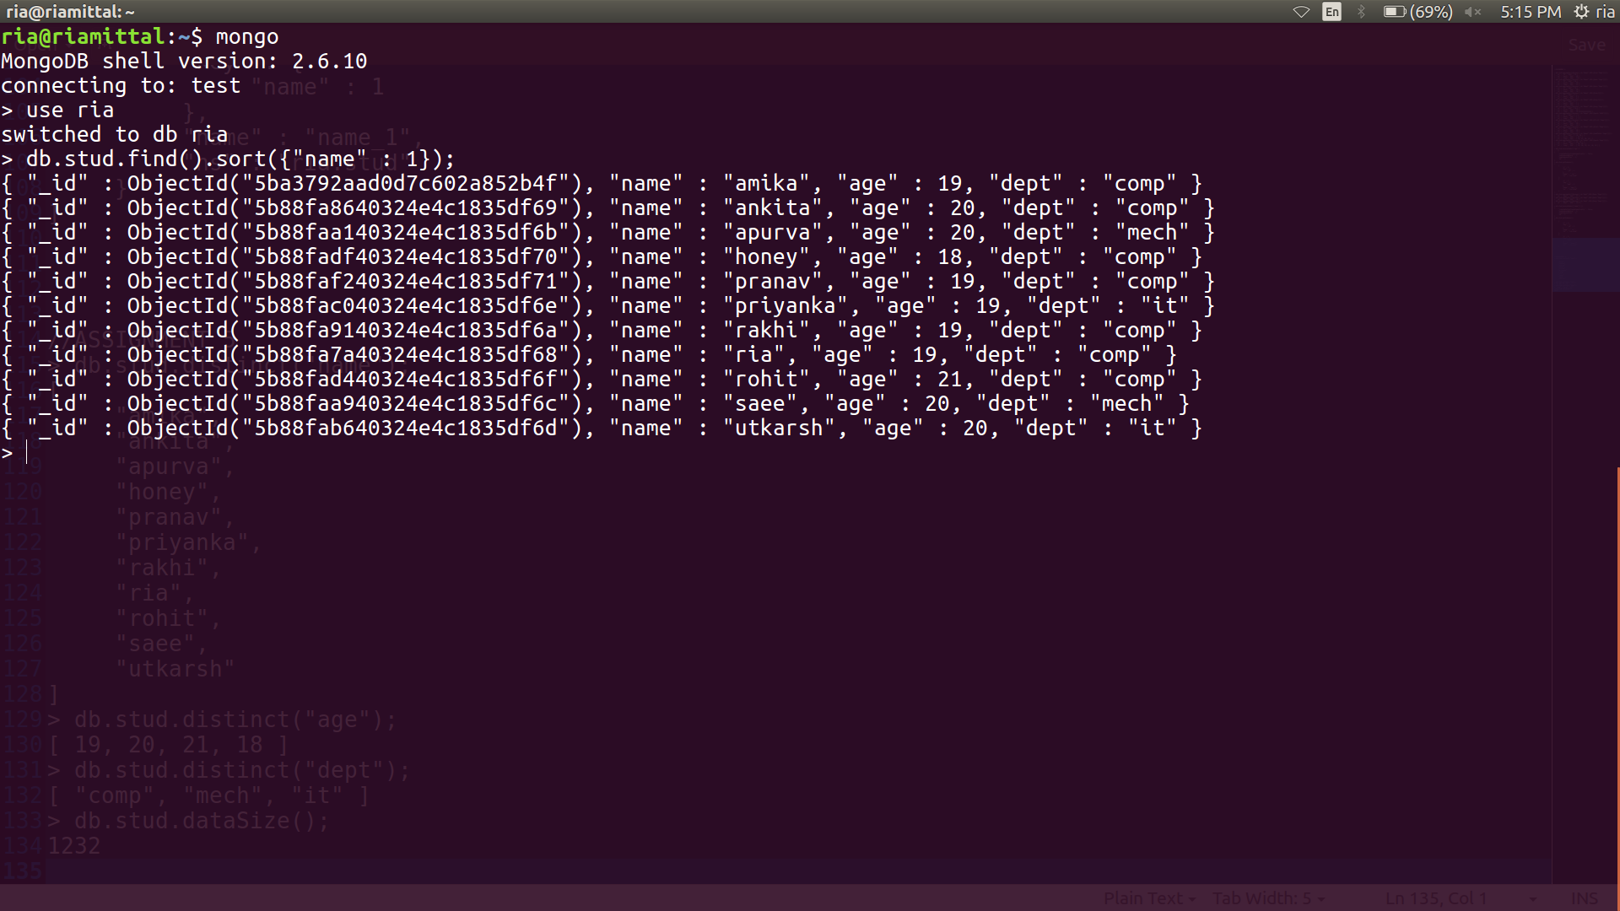

> db.student.validate(true)

{

"ns" : "ria.student",

"firstExtent" : "0:28000 ns:ria.student",

"lastExtent" : "0:28000 ns:ria.student",

"extentCount" : 1,

"extents" : [

{

"loc" : "0:28000",

"xnext" : "null",

"xprev" : "null",

"nsdiag" : "ria.student",

"size" : 8192,

"firstRecord" : "0:280b0",

"lastRecord" : "0:285b0"

}

],

"datasize" : 1232,

"nrecords" : 11,

"lastExtentSize" : 8192,

"padding" : 1,

"firstExtentDetails" : {

"loc" : "0:28000",

"xnext" : "null",

"xprev" : "null",

"nsdiag" : "ria.student",

"size" : 8192,

"firstRecord" : "0:280b0",

"lastRecord" : "0:285b0"

},

"objectsFound" : 11,

"invalidObjects" : 0,

"nQuantizedSize" : 11,

"nPowerOf2QuantizedSize" : 11,

"bytesWithHeaders" : 1408,

"bytesWithoutHeaders" : 1232,

"bytesBson" : 727,

"deletedCount" : 1,

"deletedSize" : 6608,

"delBucketSizes" : [

0,

0,

0,

0,

0,

0,

0,

0,

1,

0,

0,

0,

0,

0,

0,

0,

0,

0,

0

],

"nIndexes" : 2,

"keysPerIndex" : {

"ria.student.$_id_" : 11,

"ria.student.$name_1" : 11

},

"valid" : true,

"errors" : [ ],

"ok" : 1

}

> hostname()

riamittal

